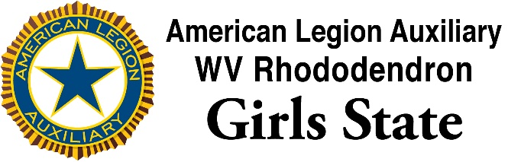

PERMISSION FOR PRESS AND NEWS RELEASE

There are many opportunities for pictures to be taken at ALA WV Rhododendron Girls State. The press will be attending many sessions of our program and the citizens write and publish a daily newsletter, The Rhododendron Daily, which will be printed at Girls State and published to www.wvgirlsstate.org, and election results and activities will be available via Twitter (@WVGirlsState) and Facebook (West Virginia Rhododendron Girls State).

We, therefore, need a release for any girl attending ALA WV Rhododendron Girls State to have their picture and name used in any of the media coverage during the week, which includes print, television, and digital formats.

I/We am/are the parent(s) or legal guardian of

______________________________________________________________________
(Please print clearly)

I do give my permission for my child’s picture or name to be used in
regards to the 2018 session of the ALA WV Rhododendron Girls State
program.

I do NOT give my permission for my child’s picture or name to be used in
regards to the 2018 session of the ALA WV Rhododendron Girls State
program.

Signature of Parent(s) or Guardian

SCAN AND UPLOAD MEDIA RELEASE FORM WITH
ONLINE REGISTRATION

