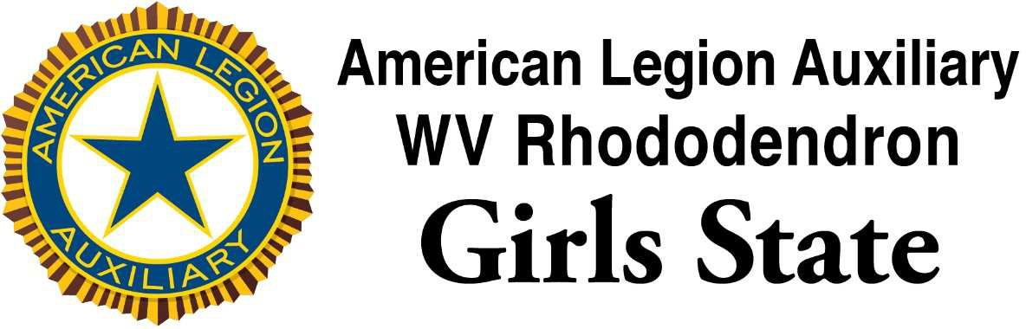

An Americanism Project in
Citizenship, Leadership, and Practical Training in Government
on the campus of Davis & Elkins College

June 12-17, 2022

Get the opportunity to meet and work with girls from across West Virginia.

Cost is $250 per person includes all materials and a RGS T-shirt

For more information see:

